***Report for CSC3150 Assignment 2***

Yang Liang 120090874

1. **Program Design Methodology**

**1.1 Program Task**

In this assignment, we are required to design a game “Frog Crosses the River” by the use of multithread programming techniques. In the game, there is a river with logs floating on it, and a frog is standing in the middle of the bottom bank of the river. It must cross the river by jumping on the logs as they pass by staggerly. The user controls the frogs’ moving directions *(upward, downward, left, right)* by keyboard, and will win if the frog jumps to the other bank of the river successfully, lose if the frog falls into the river, or the frog reaches the left/right of the river while still staying on the log. In actual implementation, the river banks will be represented by the symbols “||||||||||||||||||”, the frog is represented by “*0*”, and the logs are as “= = = =”, as shown below.

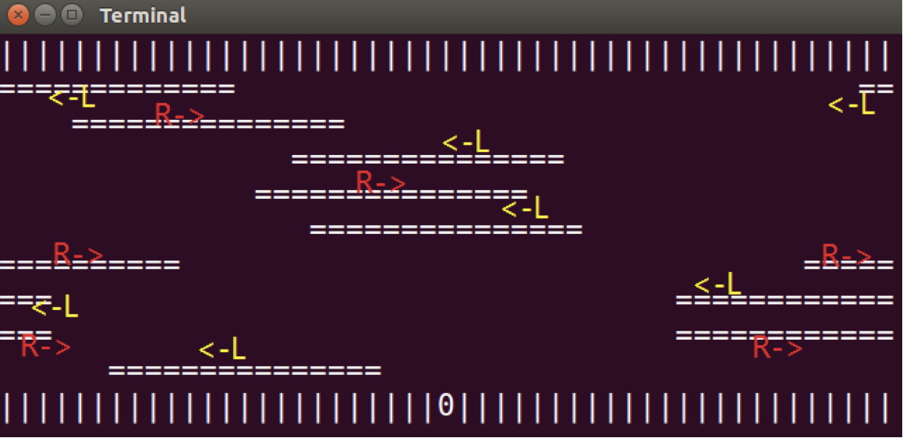

**1.2 Implementation Details**

In the actual design, we mainly need to tackle 3 aspects. One for handling the user commands of the frog’s motion, one for the stagger movements of the logs, and the other for dynamically displaying the game interface to player.

Totally 11 threads are created for the implementation, including 9 threads for tracing the movements of each log in the river, respectively (executing the function *“logs_move()”*); 1 thread for tracing the movement of the frog (executing the function *“frog_move()”*), and another 1 thread for displaying the screen (executing the function *“render_screen ()”*). The shared data (critical section) among the thread includes variable “*stop_process*”, which controls whether to terminate the execution of the game and display the final result; *“flag”*, which controls the termination status (1 for user “quit”, 2 for “win”, 3 for “lose”); and “*map”*, a 2-dimensional array that stores the information for displaying the game. In order to protect these shared data when multiple writes and modifying occur, a mutex lock *“mutex”* is created and used in my defined function *“frog_move()”*, *“logs_move()”* and *“render_screen()”*, which will be introduced one-by-one as follows.

Function *“frog_move()”* is implemented to trace the movement of the frog according to the keyboard input of users. Function *getchar()* and *kbhit()* is used to get the input moving direction from user keyboard. Changes will be described subsequently, for example, moving upwards means the “*row”* coordinate of the frog should be decreased by 1, i.e., when shown in the *map*, it is *map[frog.x – 1][frog.y] = ‘0’*, and its original position should be replaced by log or river bank, i.e., *map[frog.x][frog.y] = ‘|’*. Of course, the position change is valid only when there is log above it, else the frog will fall into river and fail the game, so we need to validate the movement. The termination of the thread is organized by variable “*stop_process”* in the loop “*while(!stop_process)”*, when the frog reaches the other bank (win) or do some invalid move that will lead it fall to the river (lose), the *“stop_process”* variable will be set to 1 so as to end the thread.

Function *“logs_move()”* is designed to coordinate the movement of the logs. Note that, logs in odd number rows move from left to right, while in even number rows logs move from right to left. Firstly, we need to specify the *start* position of each log. To make it random and start at a relatively graceful position, we may use *srand()* function to set random seeds, and *rand()* function to determine the starting positions of the logs. The following movement of the logs is controlled by the loop *while(!stop_process)*, and there are 2 moving directions. Every iteration corresponds to a single static position of the log and should be displayed by the *render_screen()* function, therefore, the mutex lock should be placed within the iteration body. It is important to refresh the whole row by setting them to empty elements “ ” at the start of each iteration. Worth mentioning, in the row of log with the frog on it, we need to coordinate with the state of the frog by the flag variable *“frog_on_log”*, which indicates whether the frog is exactly on the log (sometimes, the frog may fall out of the log into the river because of the user’s “left” or “right” moving commands), if not, the game will end and the user loses. If the frog is still on the log after the “left” or “right” movements, we need pay attention to changing the frog’s position *frog.y* instantly. For example, when the log is moving leftwards with a frog on it, the *start* position (left handside) of the log should minus one in every iteration, also we need do the same for the frog’s column information *frog.y*. Moreover, in order to make the movements of the log look smooth, the *usleep()* function is adopted to suspend execution of the calling thread, by appropriately adjust the sleeping time interval.

The display of the game interface is completed by the *render_screen()* function. It is trivial since we only need to print out the elements stored in the 2-dimensional array *map* by the *puts()* function. The dynamically display should again be organized in the loop *while(!stop_process),* one print screen in each iteration, with a mutex lock in each iteration and *usleep()* function to display gracefully.

**1.3 Bonus**

In the bonus task, we are required to implement 2 functions in thread pool, which are *async_init()* and *async_run()*. Thread pool is a way of multitask processing. In a thread pool, there are a certain number of threads, and tasks that need to be processed are arranged in a task queue, which follows the FIFO principal. Every time when there is a thread that is not busy currently, the head of the task queue will be pushed to one of the threads in the thread pool for processing. This way of implementation can maximize the use of threads by keeping them as busy as possible, and can avoid repeatedly creating and destroying threads, which is time-consuming and space-consuming, especially in cases when there are huge number of requests. Asynchronous call means that the caller doesn’t need to wait for the return result from the callee. The workflow for asynchrony may be: the caller sends out a request, after that the caller will get return immediately and can do its own task, the request will be executed asynchronously, the caller will be informed sometimes if the request has been finished.

In the actual implementation, we need to implement a thread pool where requests will be handled right away automatically whenever there is thread that is not busy. According to the principle of the thread pool, we construct 2 data structures, structure *my_item_t* is used to store a tasks list (function that needs to be called), its attributes include the *name of the function that needs to be executed*, and *the function parameters*, and the *next task* of it. The data structure *my_queue_t* is constructed for the thread pool, it includes the information of its *thread_id*, the *task list* that needs to be process, the *mutex lock* and the *conditional signals*. Here we implement 3 functions, *async_init()*, *async_run()* and *execute_routine(),* which acts as an auxiliary function.

The function *async_init()* creates the given number of threads and initializes the above 2 data structures. The function that this thread needs to be executed (the third parameter in the *pthread_create()* function) is *execute_routine()*.

Function *execute_routine()* is the worker function that exactly deals with the tasks. Tasks at the head of the *task list* will be pushed to the thread pool for implementation whenever there is a thread that is not busy. It is organized in the *while(1)* loop to keep the thread executing unless it exits. A mutex lock is placed at the start of iteration to protect share data. When there is no task coming, it goes to sleep by *pthread_cond_wait()* function. When there is work, it will pull out the tasks by sequence from the task list and execute the task according to its *function pointer* and *parameter* attribute.

The function *async_run()* mainly deals with the manipulation of the task list. When there is task coming in, it adds the tasks to the task list *my_item_t*, and will send signal by *pthread_cond_signal()* function to the worker function *execute_routine()*.

Overall, the main workflow is, we use *async_init()* function to create new thread pool and initialize the task list, the threads in the thread pool will execute the worker function *execute_routine(),* which sleeps when there is no tasks, and wakes when new tasks arrive. The *async_run()* function will then handle the task list when new tasks arrive, and send the signal to *execute_routine()* function.

1. **Program Execution Environment**
   1. **Linux Version**

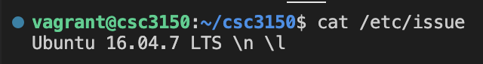

* 1. **Linux Kernel Version**

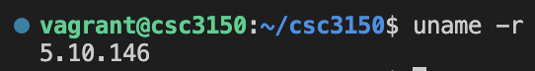

* 1. **GCC Version**

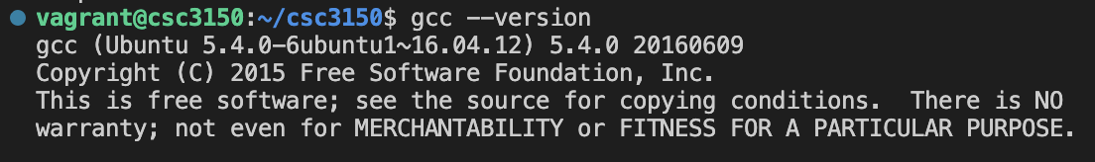

1. **Program Execution Commands**

Please use the commands below to execute the program

* 1. **For the Game (both methods are OK)**

Method 1:



Method 2: (use the Makefile I attached)

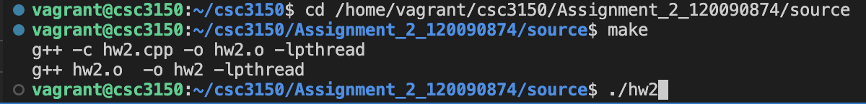

**3.2 For Bonus**

Step1: Set up a port forwarding in VS code as shown below

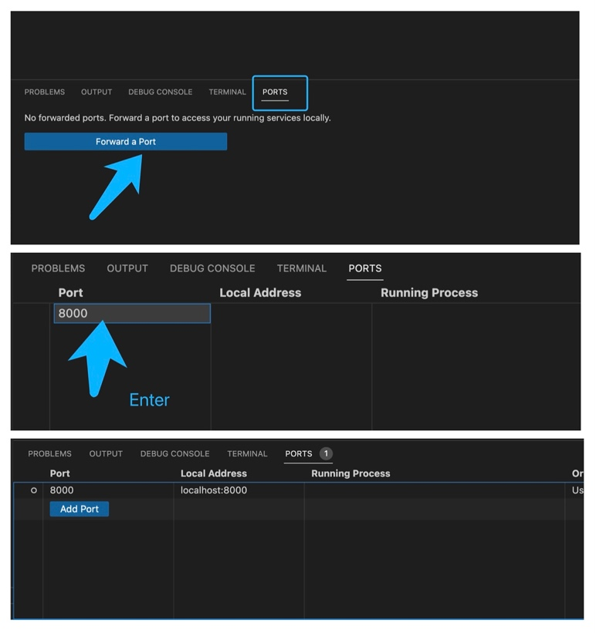

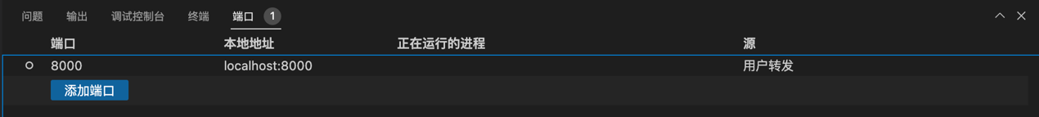

Step2: Type the commands as below in one terminal (here we use 10 threads)

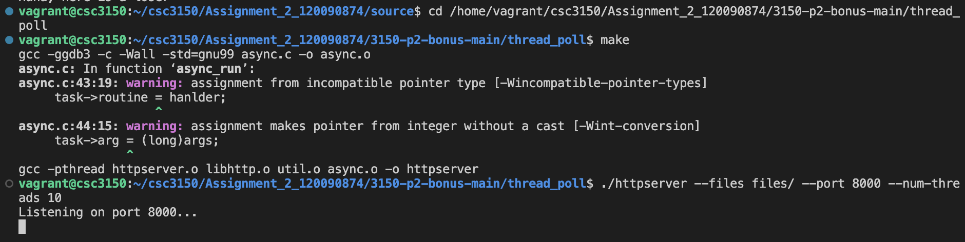

Step3: In another terminal, use the below command for benchmarking the thread pool implementation (10 threads, 500 requests for example)



1. **What is Learned from this Assignment**

Knowledge of multithread programming is consolidated after the implementation practice of this game. Now I am getting more and more familiar with multithread programming APIs such as *pthread_create()*, *pthread_join()*, and their parameters. Also, in bonus I learned about a practical type of multithread implementation - thread pool. Moreover, by handling and coordinating the threads involved in this program, I have a deeper understanding on the *mutex* mechanism and its protection on reading and writing data in the critical section. Moreover, I get to know some useful functions, such as *kbhit()*, *getchar()* and *puts()* to manage user input, and smoothen the output by appropriately adjusting the time interval in the *usleep()* function. In addition, I am more and more familiar with the C programming language and my debugging skills are improved.

1. **Screenshots of the Program Outputs**

**5.1 Output of the Game**





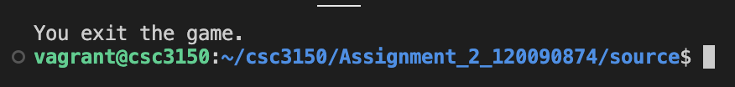

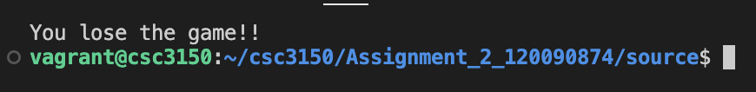

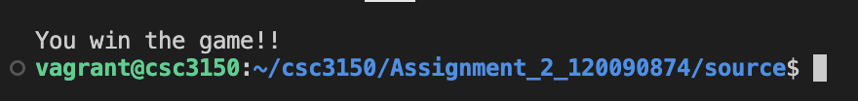

**5.2 Output of Bonus**

10 threads, 500 requests

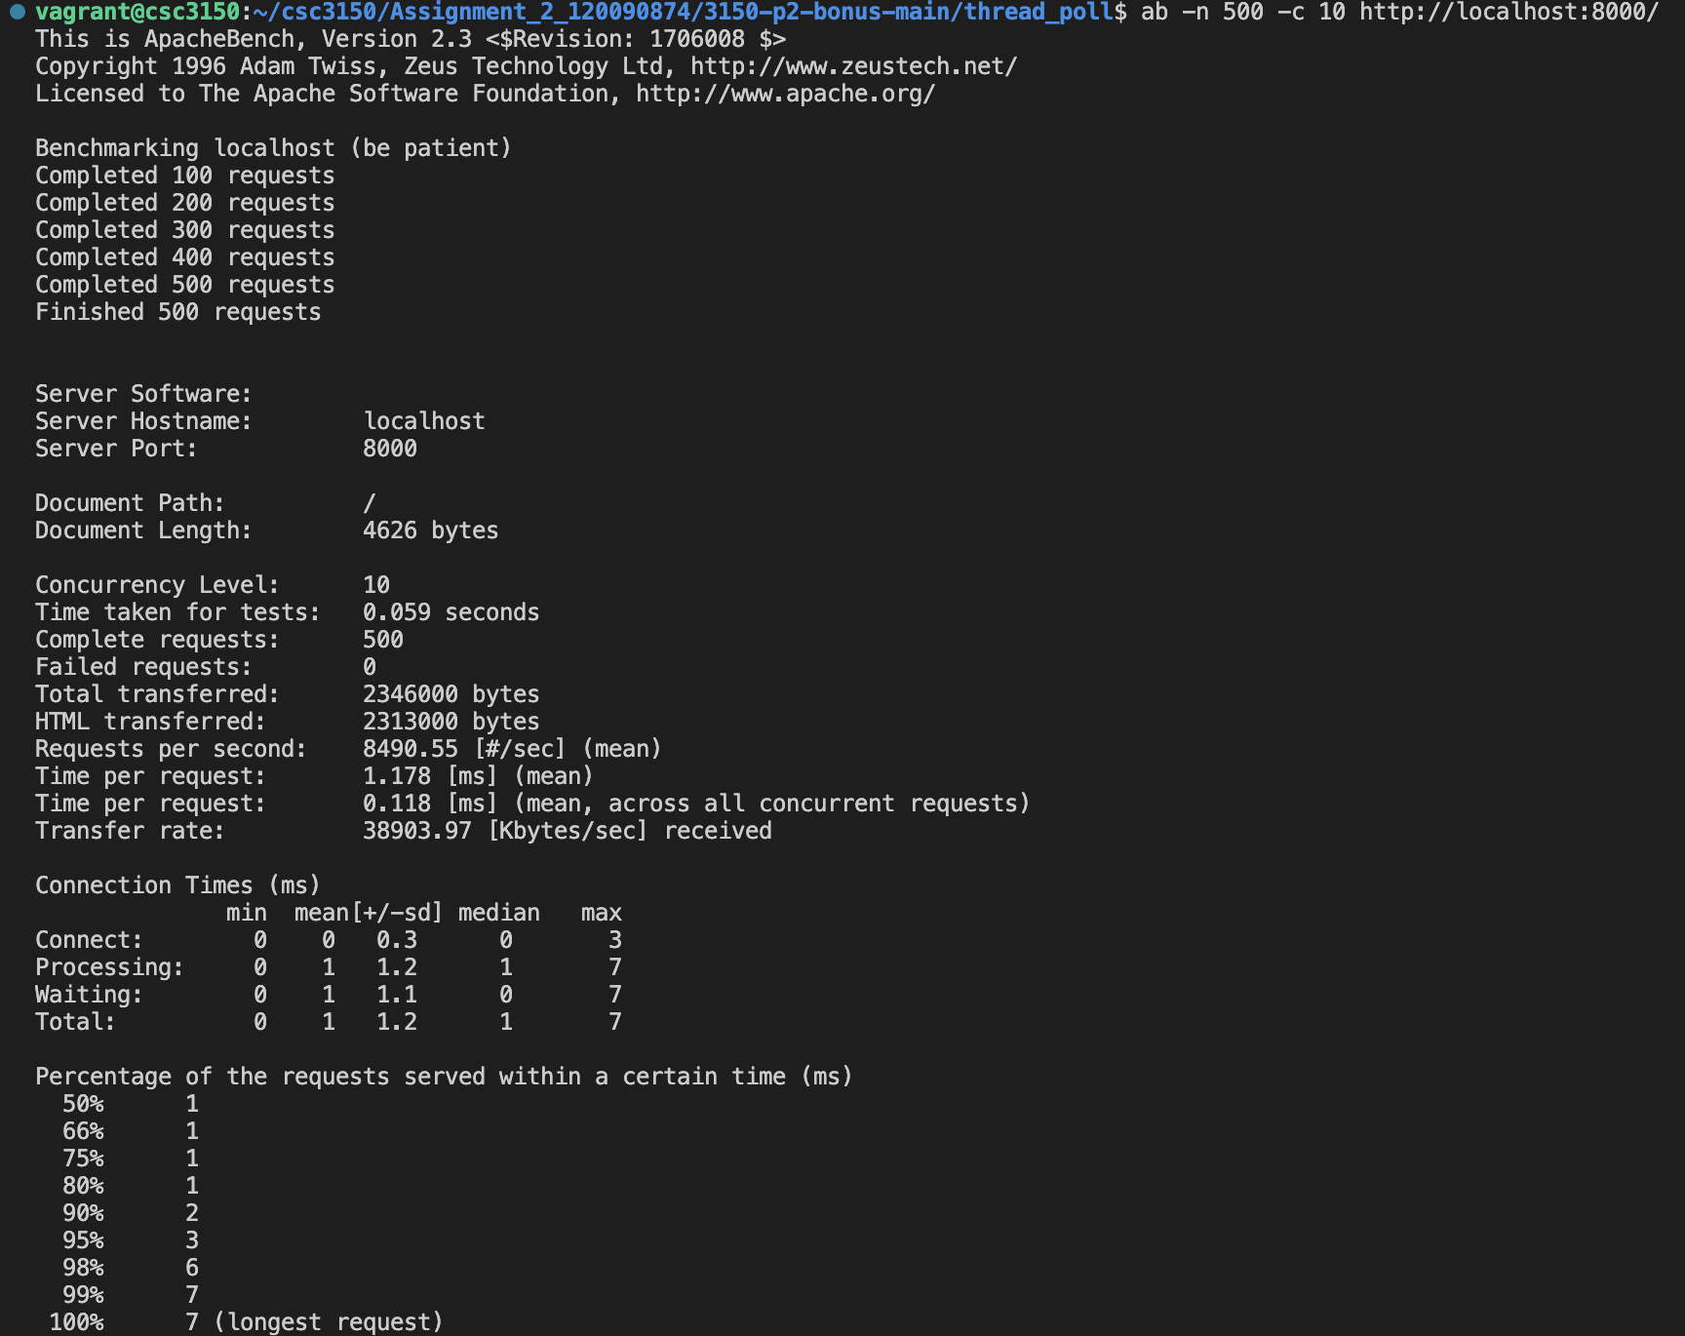

10 threads, 5000 requests

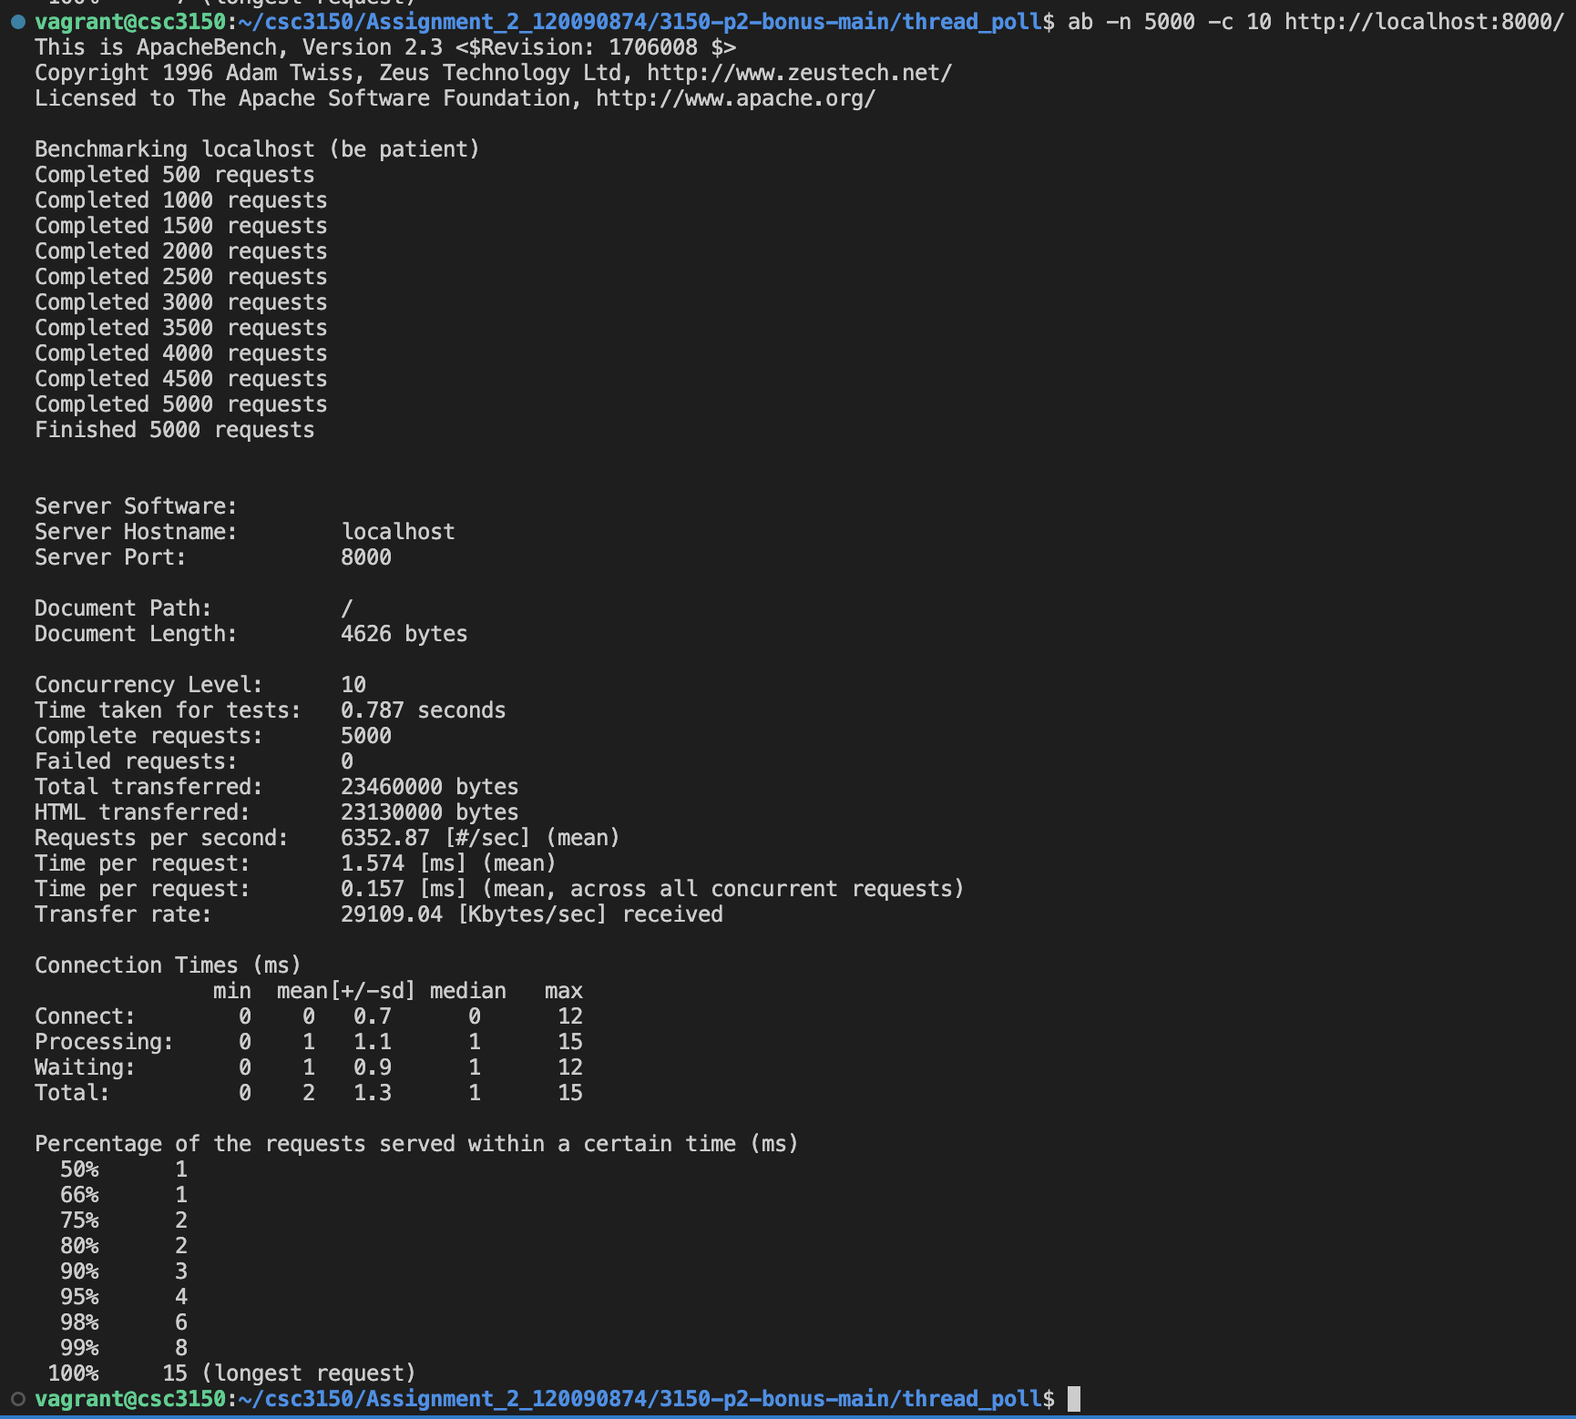

10 threads, 50000 requests

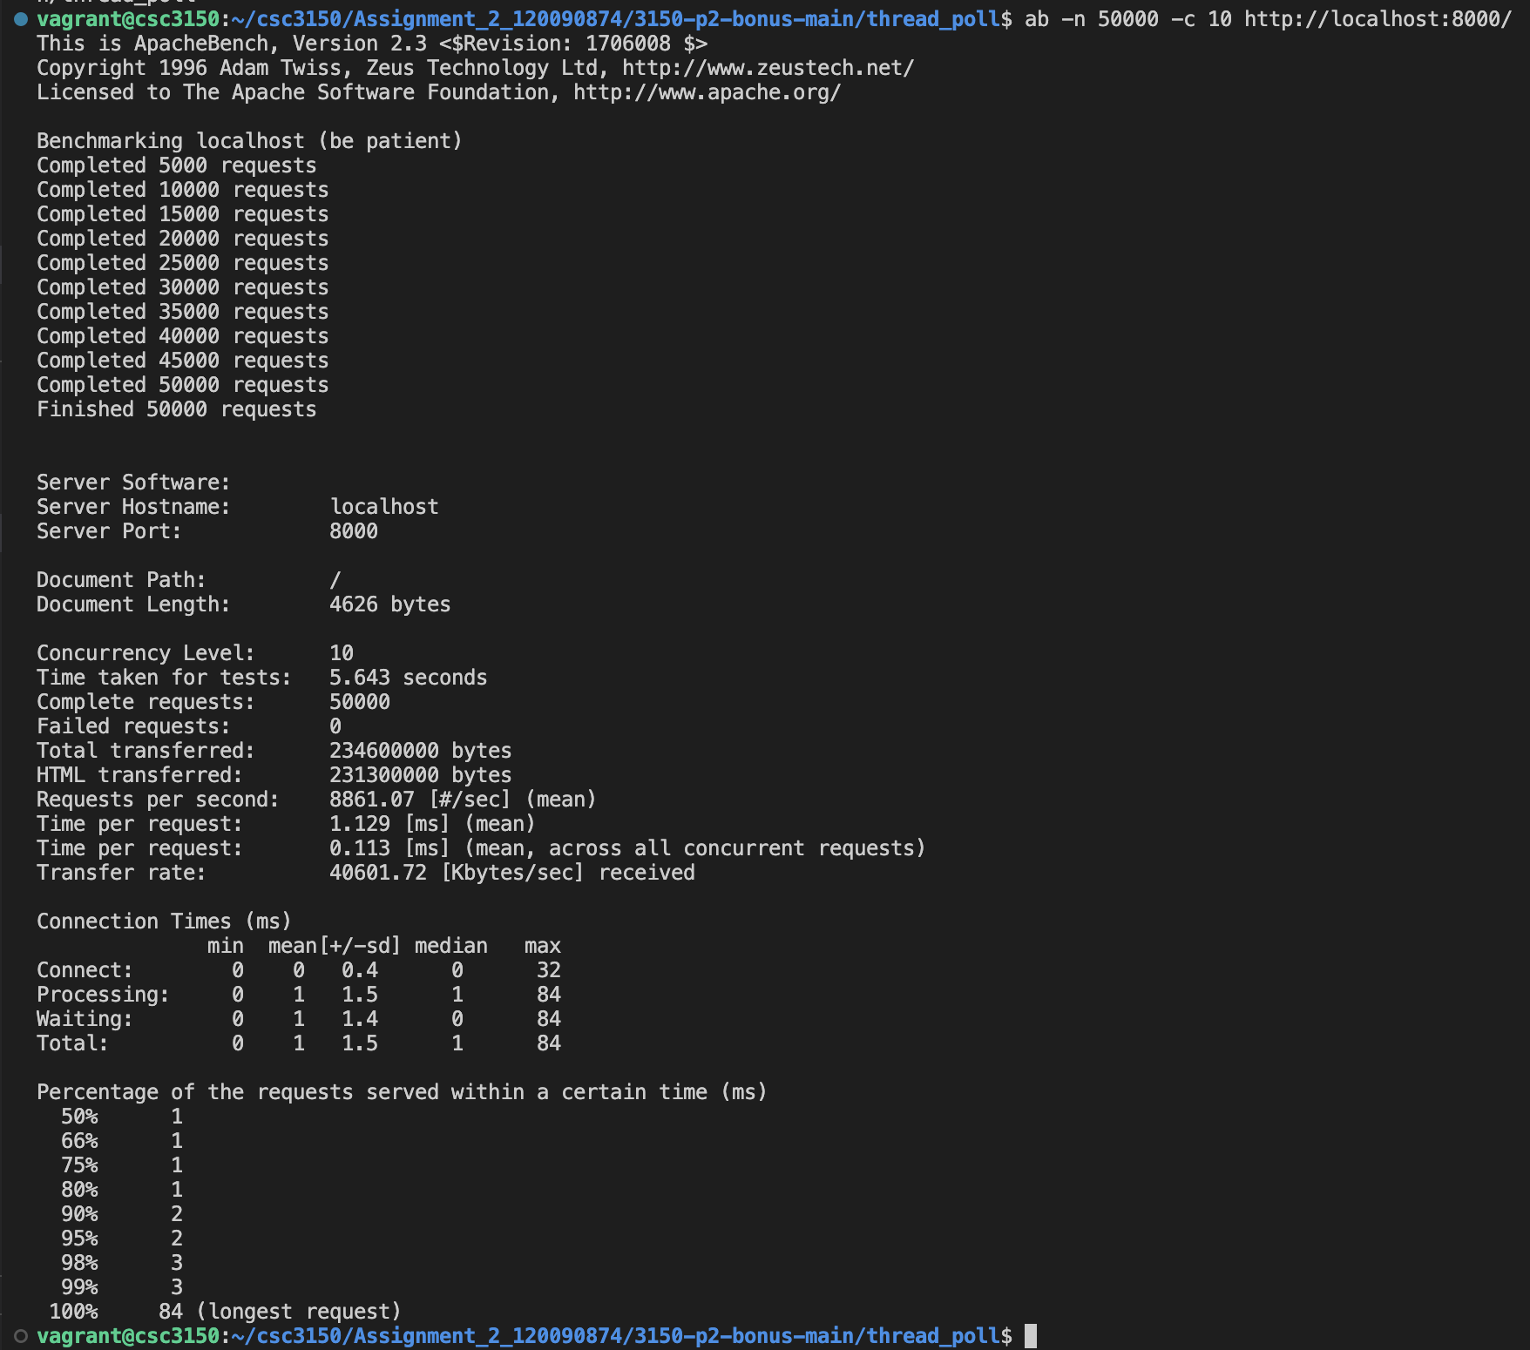

**--- End of Report ---**